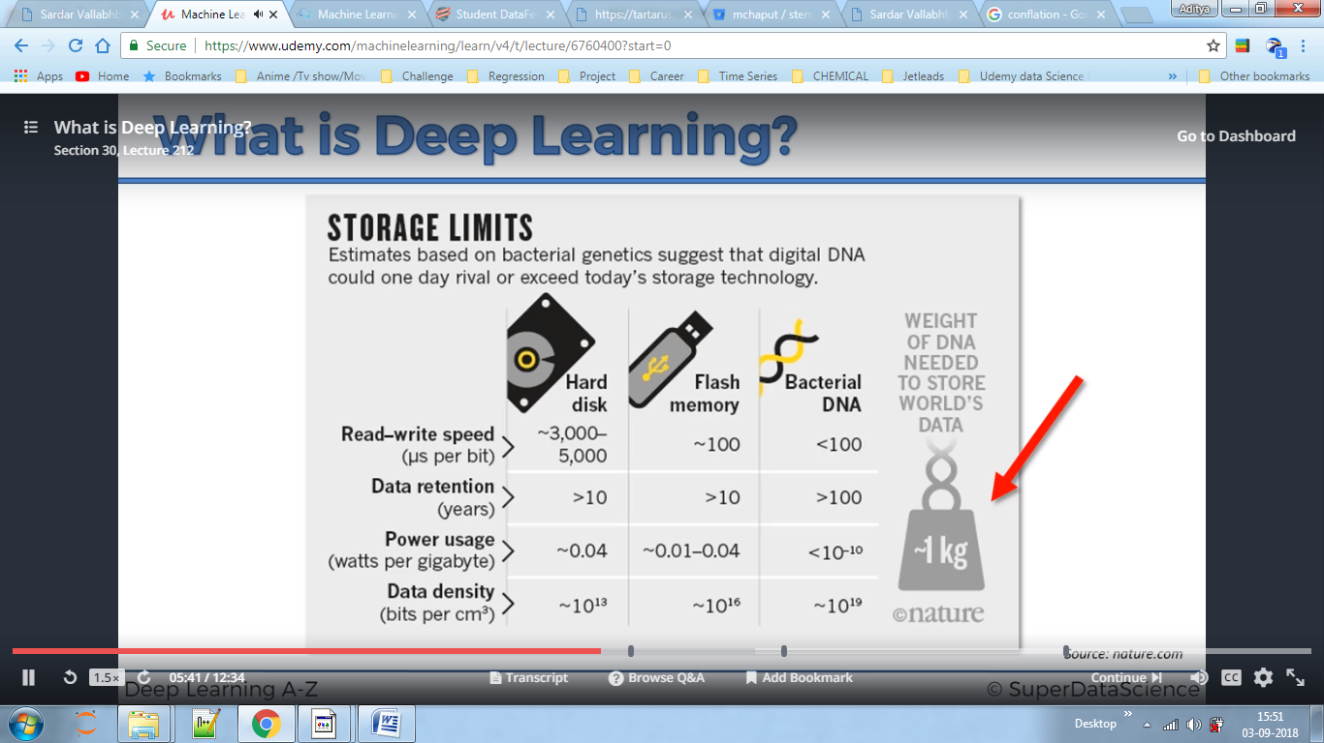

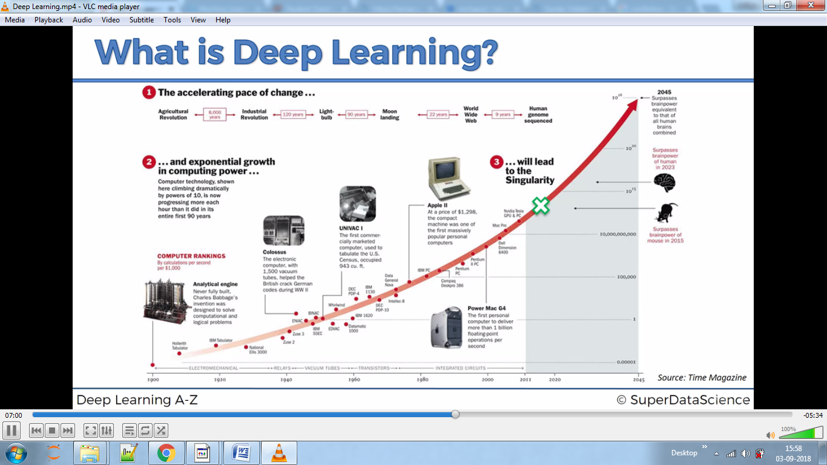

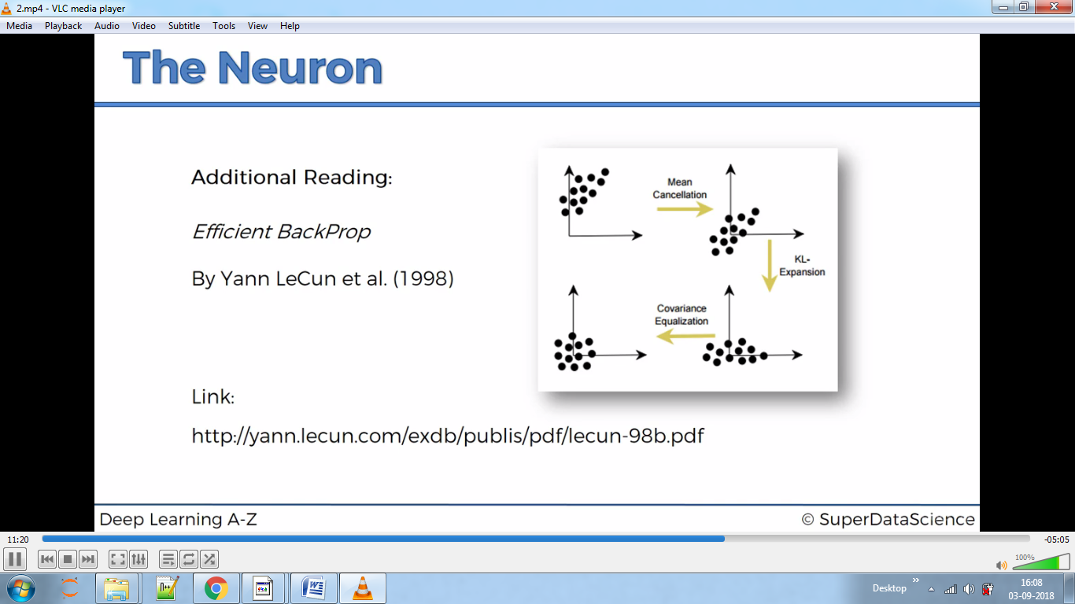Activation Function:-One of the activation functions is sigmoid.

Rectifier is mostly used as activation function

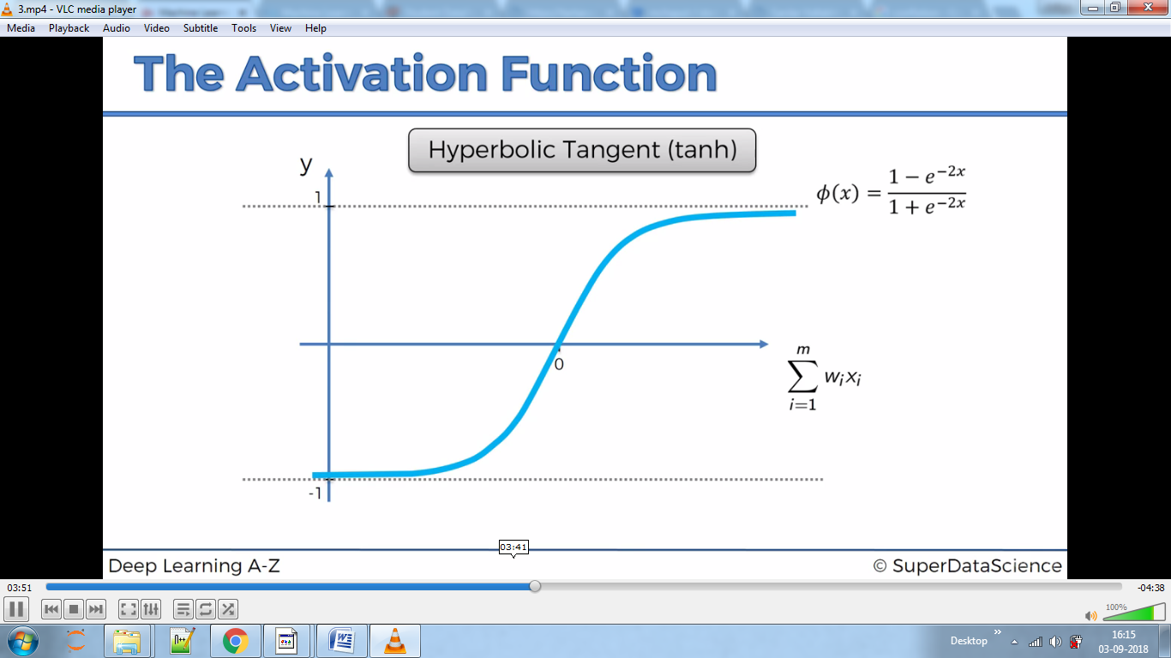

Our goal is to minimise Cost function and update the weights after each iteration, this is called back propagation.

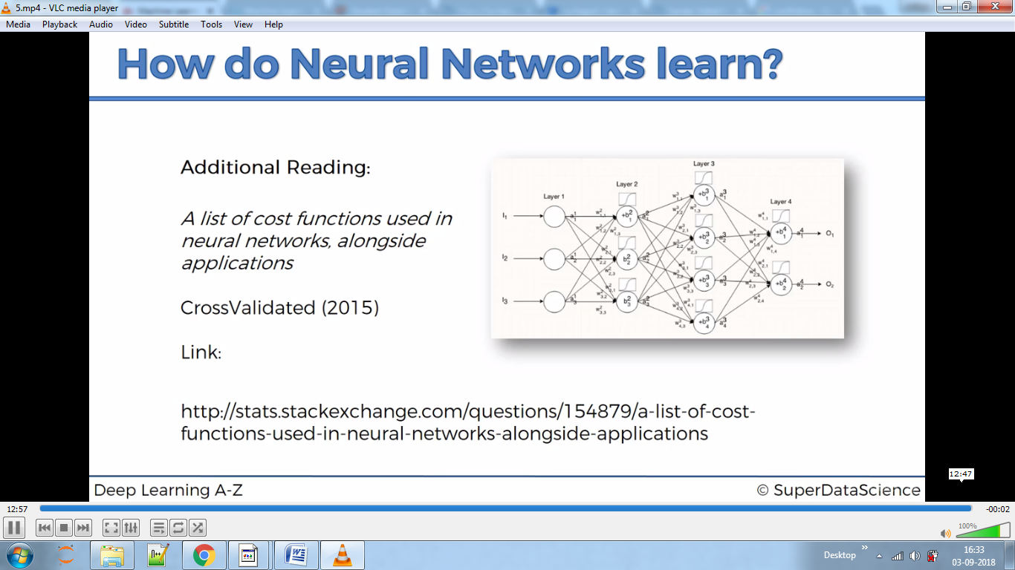

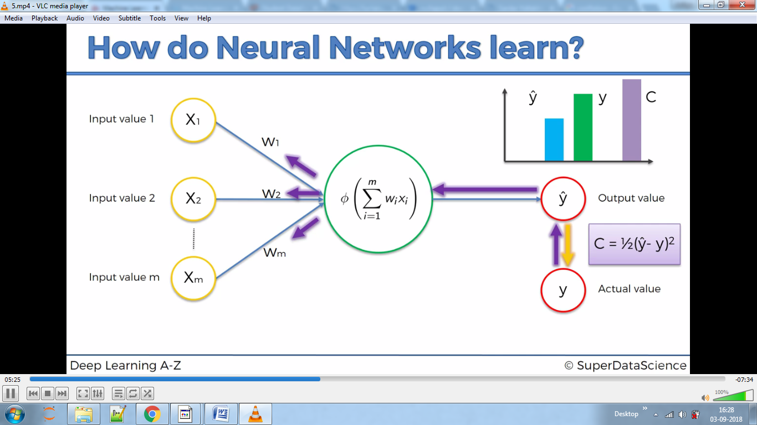

Above is Back propagation, where errors are minimised by recalculating the sum of squares again and again until we find minimum value for a cost function.

We can do this by brute forcing but it will take time, hence we use Gradient Descent Algorithm. But this sometimes gives us false result because it might reach to local minimum. To overcome this we use Stochastic Algorithm.

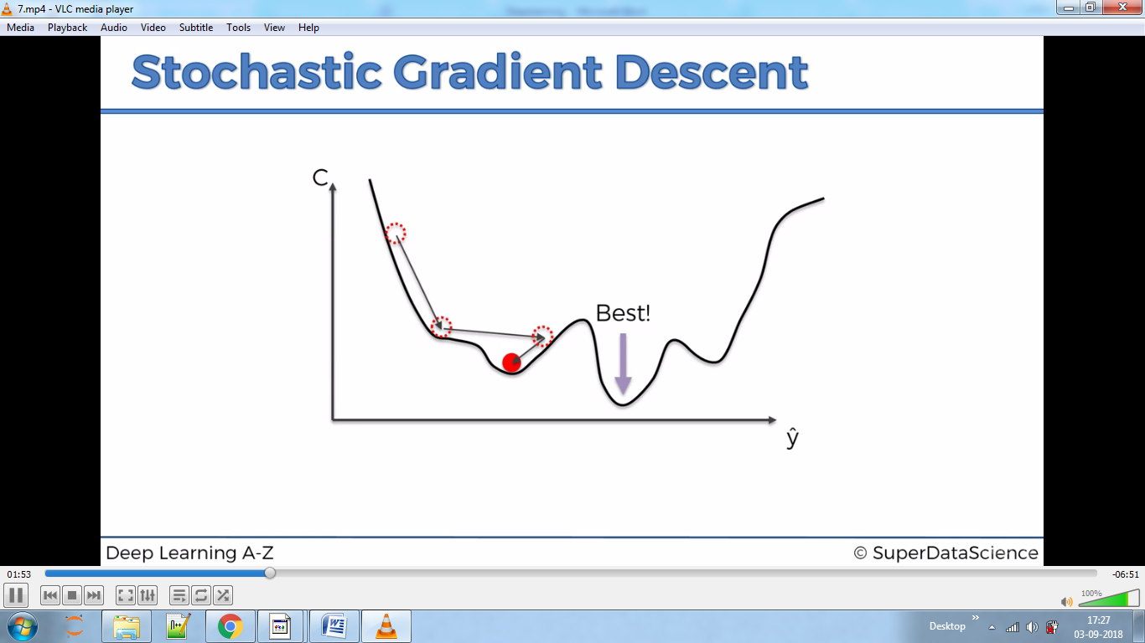

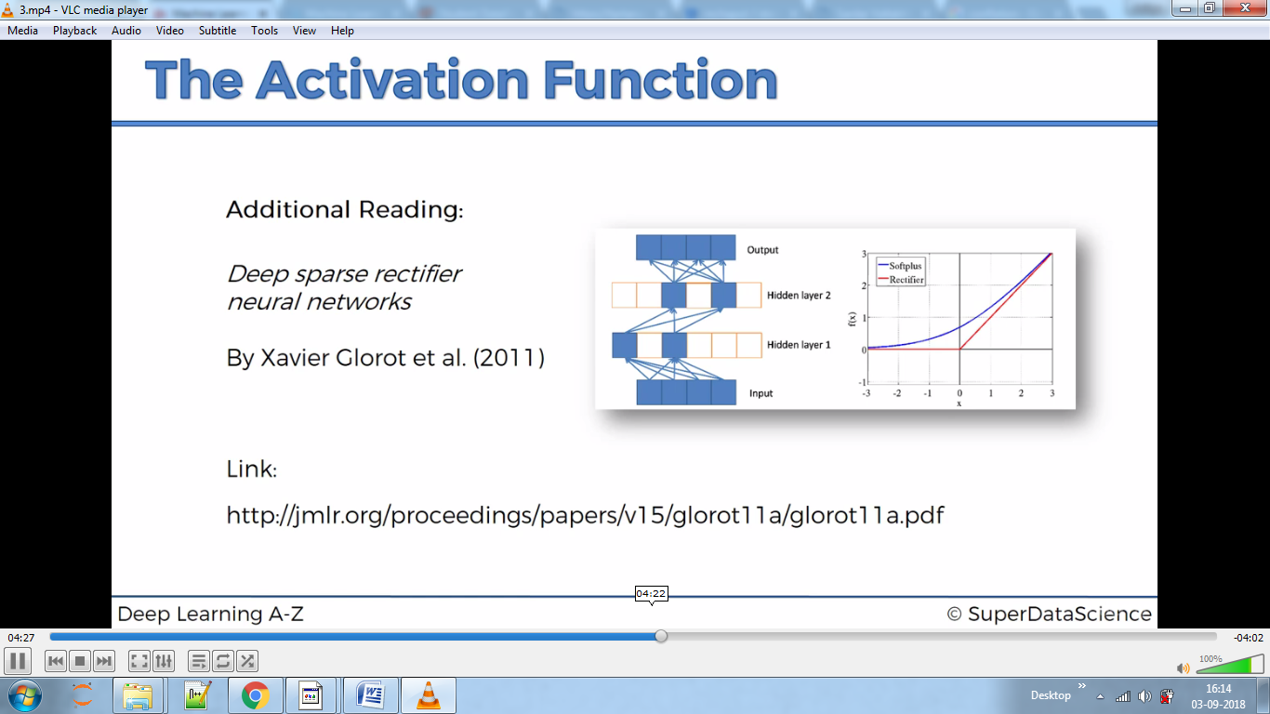

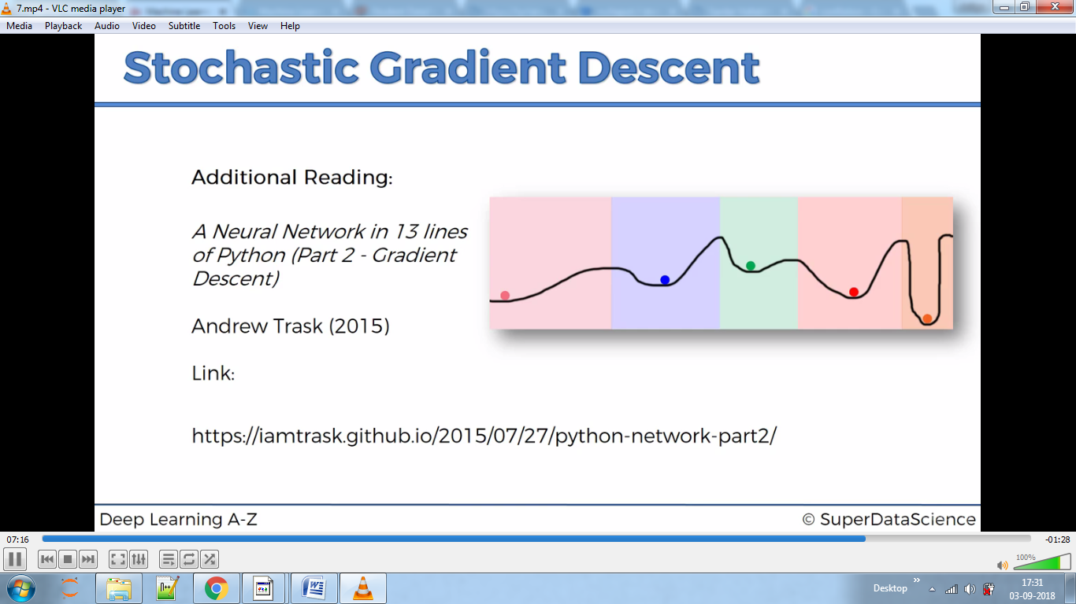

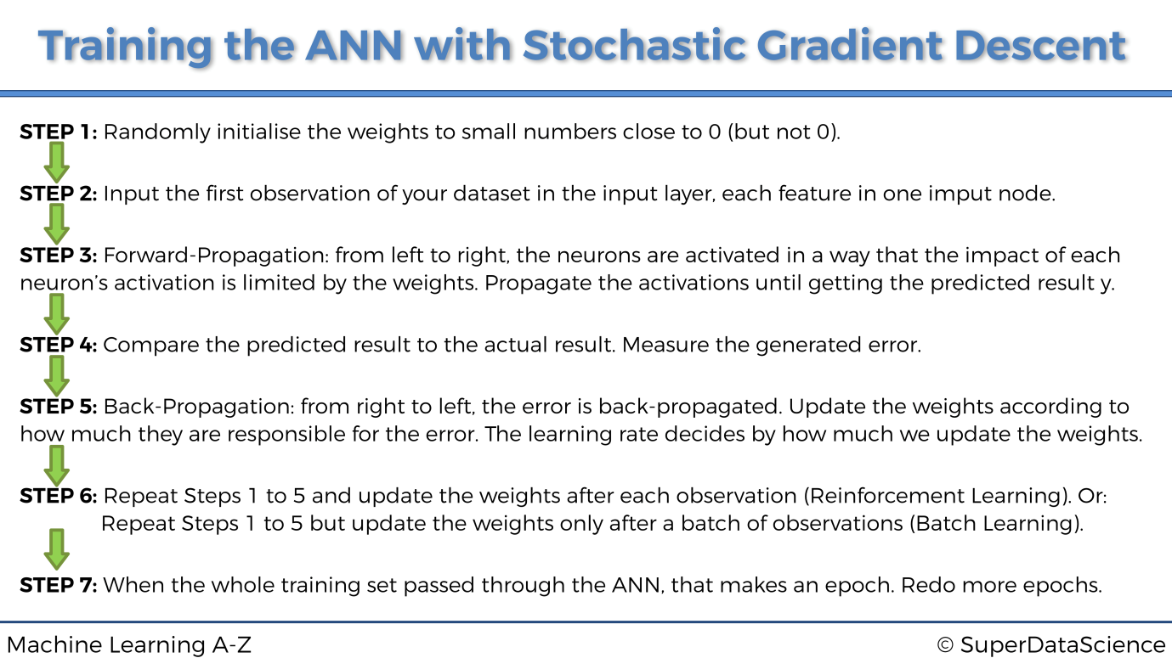

**­­ANN**

Tensorflow and theano libraries are used to build model from scratch hence we need to use Keras which combine these two models.